Lampiran 5. Surat Ijin Penelitian BAKESBANGPOL
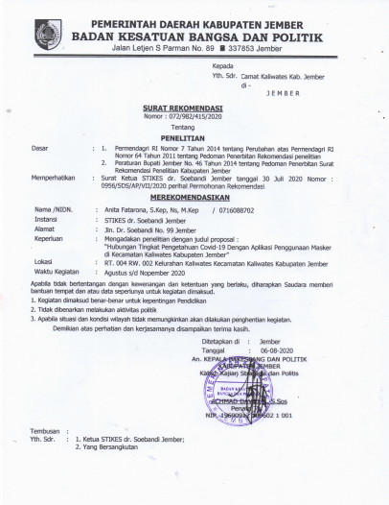

Lampiran 6. Surat Ijin Penelitian Kecamatan Kaliwates
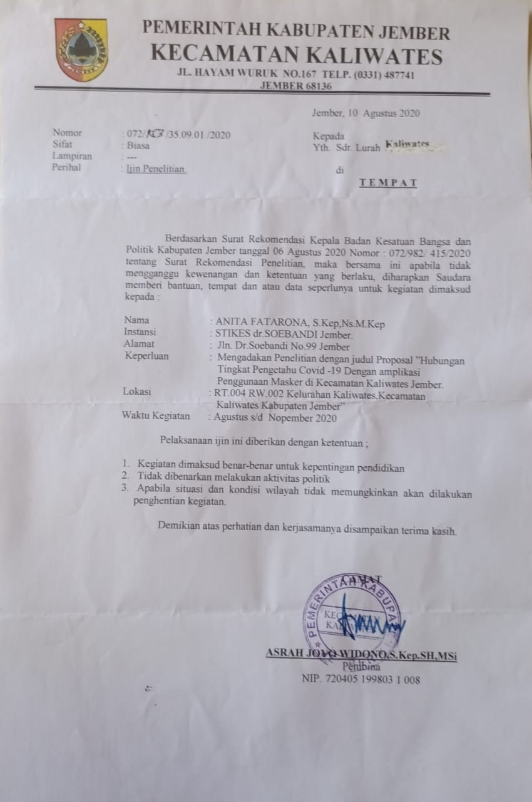

Lampiran 7. SPT
